PHISHING URL DETECTION USING RANDOM FOREST AND LOGISTIC REGRESSION ALONG WITH XGBOOST

Elangovan S
Department of Computer Science and Engineering
Nandha Engineering College
Erode, Tamil Nadu, India.
Email: elangovans008@gmail.com
Karthick C
Department of Computer Science and Engineering
Nandha Engineering College
Erode, Tamil Nadu, India.
Email: karthikcts17@gmail.com

Aravind L
Department of Computer Science and Engineering
Nandha Engineering College
Erode, Tamil Nadu, India.
Email: aravindlingeswaran007@gmail.com

1.Abstraction
In today’s world, many cybercrime attacks occur as a result of the rapid revolution in technology and approximately 200 million websites are active globally at any time. Hence, this study mainly focuses on Phishing URL detection. Although scam was first used in 1990’s, it has become the most fear and dangerous cybercrime attack on the internet [1]. By using the unknown structure of the Internet, attackers set out new process to enter into our system, to deceive victims with the use of false websites to collect their sensitive information such as account IDs, usernames, passwords, etc. It is hard to know whether the web page is real or fake so it is very helpful for the attacker. Although software companies continue to launch new anti-phishing products using blacklists, heuristics, visual analysis, and machine learning-based approaches, these solutions still cannot prevent all phishing attacks [2]. The limitations of traditional security management technologies are becoming increasingly serious due to the exponential growth of new security threats, rapid advancements in IT technologies, and a significant shortage of security professionals. In this paper we are going to see about the phishing URL detection model using machine learning algorithms.

Keywords
PhishingURLdetection, RandomForestClassifier, XGBoostClassifier, LogisticRegression, cybersecurity, URL-based feature extraction, threat intelligence, fraud detection, data-driven security.

2.Introduction
In this model, we have used RandomForestClassifier and LogisticRegression along with XGBoostClassifier to predict the URL is phishing or not. There were many research papers available in this topic but with the use of different combinations of machine learning algorithms for the prediction. We have trained a model with a new combination of algorithms and tried to make predictions with good accuracy rate. URL Stands for Uniform Resource Locator, which is the address used to access resources on the internet also uses the HTTP protocol. It mainly has two components: 1. Protocol identifier (indicates what protocol to use) 2. Resource name (specifies the IP address or the domain name where the resource is located [3]. Blacklisting is a type of Conventional that deals with the scam websites that provides better results [4]. The scam URLs are sent to the user thought emails and message [5].

Example of URL
https://www.example.com:443/products/item1?id=123&sort=asc#reviews
1.Scheme:
This indicates to the browser how to connect to that website.
In this example it is https, meaning that it is a secure connection and there is no one interruption between you and the web server.
2.Host:
This is the site being visited, or server.
For this example, it is www.example.com; that's your site.

3.Port:
The port is like a door you open to communicate with the site.
:443 is the default port for secure HTTPS connections, so it is usually hidden in common browsing.
4.Path:
This gives you the page or file you are viewing on that site.
For example, /products/item1 could be the contact us page.
5.Query String:
After, there is some extra information that is being sent to this page.
In this example, id=123 & sort=asc tells the site to return product #123 with results in ascending order.
6.Fragment:
The fragment tells you that you are being directed to a section of the page.
In this example, #reviews might take you directly to the reviews section for that product.

Related Works
1.Marwa Abd Al Hussein Qasim, Dr. Nahla Abbas Flayh (2023).
In this paper, they have used various algorithms like Decision Tree, Support Vector machines, Random Forest and Naïve Bayes to identify the phishing websites effectively. This paper doesn’t provide a new model but it serves a good research paper for different studies.
2.Md Robiul Islam, Md Mahamodul Islam, Mst. Suraiya Afrin, Anika Antara, Nujhat Tabassum, Al Amin (2024).
In this paper, they have proposed a PhishGuard using 1D Convolutional Neural Network (CNN). This paper is trained using large dataset and achieves a high accuracy of 99.85%. This helps to demonstrate deep learning with good transparency in decision making.
3.Aditya Kulkarni, Vivek Balachandran, Dinil Mon Divakaran, Tamal Das (2024).
In this paper, they have introduced PhishOracle, a framework that creates phishing websites and evaluates the LLMs model. The result in this study has proved that many model fails and fooled by attacks. This paper doesn’t provide a algorithm to solve it but highlights the issues in the models.

3. Methodology
This model is designed to detect scam URLs using machine learning. We develop this model, using the following steps: data collection, data preprocess, model train, model evaluation and predict in real time. Each step improves relative accuracy of the model.

3.1 Data Collection
The project used a dataset containing URLs categorized as either phishing or legitimate. The dataset included the (very) different characteristics of each URL, such as URL length, domain aspects, and other features to signify if the URL is suspicious or legitimate. The dataset was collected from the Kaggle.

3.2 Data Preprocessing
Data prepossessing assures that the data is properly ready to training for the model. This is what we did:
Feature Extraction: We developed a function which allowed us to extract the features we wanted from each URL. The features we developed were:
- Whether the URL contains an IP address or not.
- The length of the URL.
- If the URL has been shortened, i.e. Bit.ly.
- The presence of special symbols or characters such as "@, or "//."
- The number of dots or dashes (.) in the URL.
Label Encoding: The labels (Phishing or Legitimate) are converted to numerical values that the model will understand.
Splitting Data: We split the data into training and test sets. 80% of the data was used to train the model, and 20% was used to test it. The total number of dataset present is 9144 and we used 7315 for training and 1829 for testing the model.
Scaling the Features: We took the numerical features and scaled them so all the values are on a similar scale and this will facilitate model performance.

3.3 Model Training
We ran three machine learning models to make predictions on the data set.
Random Forest Classifier: A popular method that uses multiple trees/decision trees to obtain better predictions.
Logistic Regression: A simple model to predict the odds of a URL being phishing or legitimate.
XG Boost Classifier: A high-performance algorithm that is well suited for working with structured data like the data set we were working with.
An ensemble model was formed by taking the three models and combining the models using an ensemble voting approach (soft voting).
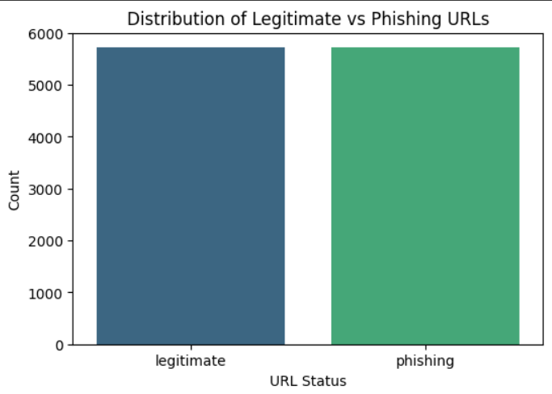
Figure 3.3 (a) Distribution of legitimate and scam URLs
In the above bar graph 3.3(a) shows X-axis has two categories legitimate and phishing and Y-axis shows number of URLs for each type. Both has nearly equal height that means each has equal amount of data. Due, to the balance in dataset the model can predict the correct output.

3.3.1 Heat Map
A heatmap is used to show the relationships between the attributes in a dataset. It helps identify which attributes are closely related to the target variable, which can guide feature selection and improve model accuracy.
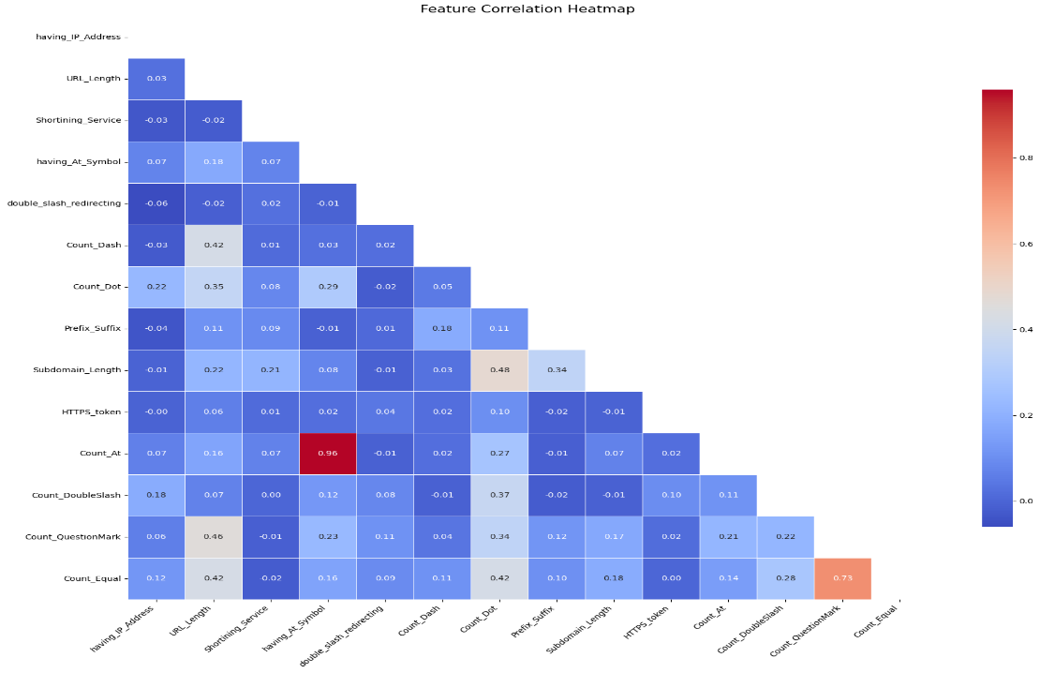
Figure 3.3 (b) Feature Correlation Analysis Using Heatmap

The above heatmap 3.3(b) shows X-axis and Y-axis represent the following futures from the dataset such as having_IP_Address, URL_Length, HTTPS_token, Count_@ etc. Blue shade represents the weak to moderate correlation. Red shade represents the strong correlation. Light colour or White colour shade represent the weak correlation. Count_@ and Shortening_Service has high correlation. Count_QuestionMark and Count_Equal has moderate correlation. Other features have lower correlation.

3.3.2 Confusion Matrix
The confusion matrix is a table that shows the classification of the case where a model correctly predicts a phishing URL which is denoted as True positive (TP), while a case where a URL is wrongly classified as legitimate is denoted as True negative (TN). There is also a case where a URL is classified as phishing is denoted as False positive (FP). Lastly a case where a URL is wrongly classified as a legitimate URL but is phishing in real sense is denoted as False Negative (FN) [6].

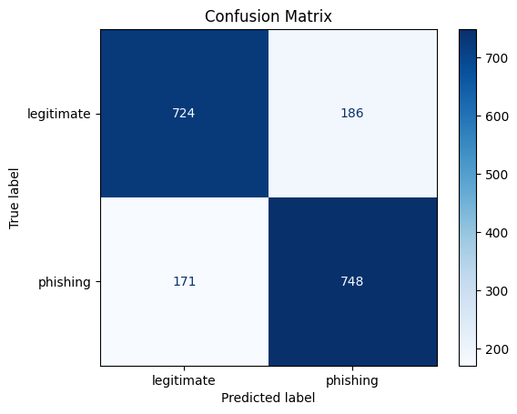
Figure 3.3 (c) Confusion Matrix graph

The above Confusion Matrix graph 3.3(C) shows how many true positive, true negative, false positive and false negative are in the matrix.

 | Predicted Legitimate | Predicted Phishing
Actual Legitimate | 724 (True Negative) | 186 (False Positive)
Actual Phishing | 171 (False Negative) | 748 (True Positive)

3.3.3 Receiver Operating Characteristic (ROC) Curve
A ROC curve is a basic tool used for evaluate the test evaluation. It's a common graph used for classifying overall possible thresholds. The graph is generated by plotting the true positive rate (TPR) on the y-axis against and the false positive rate (FPR) on the x-axis as the threshold. ROC curves can also be used for comparison between 2 points x and y-axis of the graph [7].
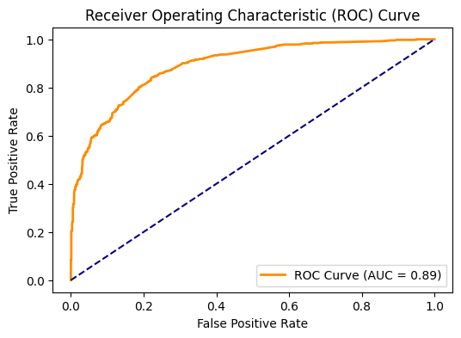
Figure 3.3 (d) Receiver Operating Characteristic Curve

The above Receiver Operating Characteristic Curve 3.3(d) denotes X-axis as False Positive Rate and Y-axis as True Positive Rate. The orange curve is the ROC curve of our model and the blue curve represents the random classifier. AUC stands for Area Under the Curve and the value is 0.80. This means that there is an 89% probability the model will rank a randomly selected phishing URL higher than a randomly selected legitimate one. AUC value between 0.80 to 0.90 it is known as good.

3.4 Model Evaluation
Once the model is generated, we tested the model using the test data.
Used measures are as follow:
Accuracy: The number of URLs the model classified correctly.
Classification Report: A detailed report that shows how well the model is doing, including precision, recall, and F1-score, which help us understand how well the model is distinguishing between phishing and legitimate URLs.

3.5 Real-time URL Prediction
The model can also make predictions on new, real-time URLs. Here’s how it works:
- The user enters a URL.
- The model extracts the same features from the URL.
- The model then classifies the URL as scam or legitimate based on what it has learned.
- The result is shown to the user immediately.

3.6 Model Saving and Deployment
After training the model and getting good results, we save it for future use. This includes saving:
- The trained ensemble model so we can use it later.
- The scaler to make sure future inputs are scaled the same way.
- The label encoder to interpret the model’s predictions correctly.

3.7 Real-time Use
In real-time, the model can be used to classify URLs as they are encountered, providing quick decisions about whether a URL is phishing or not. This makes it ideal for integration into tools like web browsers or security software, where immediate feedback is important.
This approach ensures that the model can accurately identify phishing URLs and make real-time predictions, keeping users safe from malicious websites.
4. Result And Discussion
The model was able to achieve an accuracy of 81% on the test data, which means that it can tell which URLs are phishing and which are safe. This demonstrates the model's ability to identify links that are scams based on the way the URL is formatted. The model used a combination of three machine learning models-Random Forest, Logistic Regression, and XG Boost-to make even more accurate predictions.
The model was also able to achieve good values for precision and recall, where precision is the ability to make the right call on a phishing link when the model says it is phishing, recall means the model is able to identify the phishing links from the data and the f1-score shows a good balance between the two, indicating the model can make accurate decisions and is consistent.
Finally, we also tested the model with the ability to accept real-time URL input, where a user can type or paste any URL-instantly able to tell the user if the URL is suspicious or not. The model identifies the URL based on various components of the URL-like its use of special characters, number of dots, and shortening services- and weighs all of its training.
The results are revealed in a simple message indicating to the user whether the link is safe to click or possibly a scam.

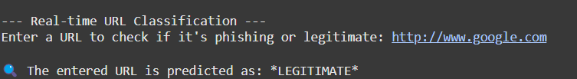
Figure 4 (a) Example for Legitimate URL
Figure 4 (b) Example for Phishing URL
The above figure 4 (a) and 4 (b) gives two different output and the both predicted output of the model is correct.
5. Conclusion
Through this project we were able to show how machine learning can be effective in identifying URL scams. We successfully built a machine learning model that was accurate by following the correct procedure and utilizing a labelled dataset of URLs, feature extraction, scaling, and training models using Random Forest, Logistic Regression, and XG Boost.
Therefore, our model can able to predict whether a URL is phishing or not with a good accuracy rate of 81%, which is achieved using the combinations of different algorithms that are not done before. This reinforces a level of usability and is also reinforces a sense of value to the system in real-world applications in aiding individuals to avoid Internet scams.

References

[1] Karim, A., Shahroz, M., Mustofa, K., Belhaouari, S. B., & Joga, S. R. K. (2023). Paper named phishing Detection System Through Hybrid Machine Learning Based on URL. It was published on 2023 IEEE Access.

[2] M. Rezaei and S. Jadidi. A paper named Detecting Phishing Websites Using Machine Learning: An Experimental Study, International Journal of Artificial Intelligence, it was published on 2020.

[3] Saini, H., & Anuradha. (2022). Paper named hybrid model for detecting phishing websites using machine learning. In 2022 it was published in 6th International Conference on Computing Methodologies and Communication (ICCMC). IEEE.

[4] Paper named stacking ensemble approach for phishing website detection using URL-based features written by Md. Arafatur Rahman, Md. Mofijul Islam, Md. Al-Mamun, Sheikh Iqbal Ahamed Published in: Journal of King Saud University - Computer and Information Sciences on the year 2020.

[5] Gupta, R., Jain, A., & Mishra, R. (2020). Paper named Malicious URL Detection using Machine Learning: A Review. International Journal of Computer Applications, it was published on 2020.

[6] Pan, Y., & Ding, X. (2006). Paper named Anomaly Based Web Phishing Page Detection. In Process of 22nd Annual Computer Security Applications Conference (ACSAC'06).

[7] Awasthi, A., & Goel, N. (2022). Paper named Phishing website prediction using base and ensemble classifier techniques with cross-validation. Cybersecurity, 5(22).

[8] Marwa Abd Al Hussein Qasim, Dr. Nahla Abbas Flayh (2023). Paper named Phishing Website Detection Using Machine Learning: A Review.

[9] Md Robiul Islam, Md Mahamodul Islam, Mst. Suraiya Afrin, Anika Antara, Nujhat Tabassum, Al Amin (2024). Paper named PhishGuard: A Convolutional Neural Network Based Model for Detecting Phishing URLs with Explainability Analysis.

[10] Aditya Kulkarni, Vivek Balachandran, Dinil Mon Divakaran, Tamal Das (2024). Paper named. From ML to LLM: Evaluating the Robustness of Phishing Webpage Detection Models Against Adversarial Attacks.

